**SMART IRRIGATOR**



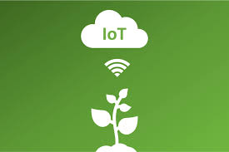

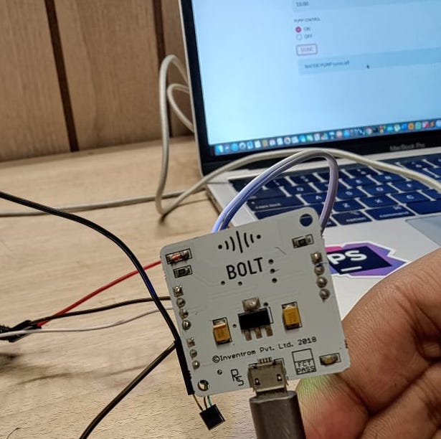

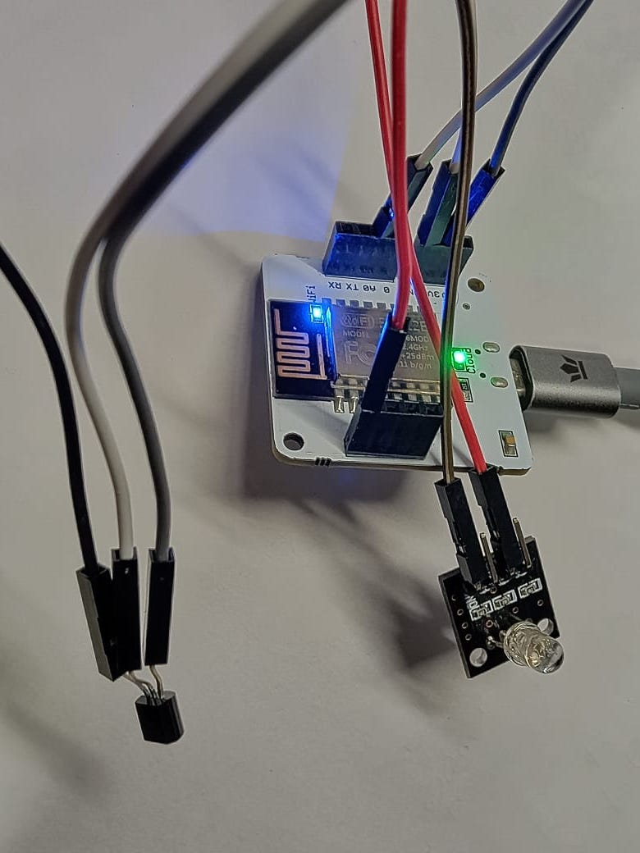

# **Things used in this project**

# **Hardware components**

1. Bolt IoT WiFi Module
2. USB-A to Mini-USB Cable
3. LM35 Temperature
4. RGB LED (For Demonstration in Place of Water pump)
5. Male to Female Jumper wires
6. Breadboard
7. Relay

# **Software apps and online services**

1. Python Programming
2. Bolt Cloud APIs
3. Msg91 API
4. Nexmo API
5. Dark sky API
6. Streamlit Framework
7. WebScraping
8. AWS EC2
9. AWS Lambda

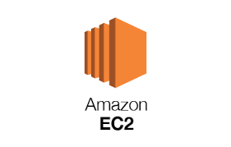 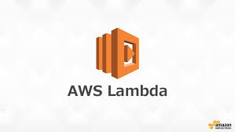

 





**LM35 (Temperature Sensor)**

***CODE FOR SENDING SMS AND CALLING***

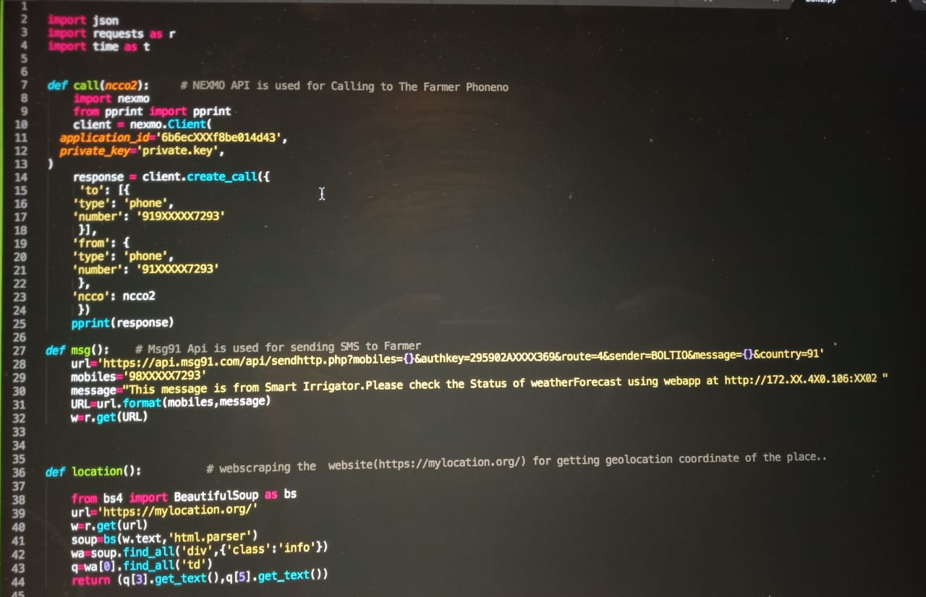

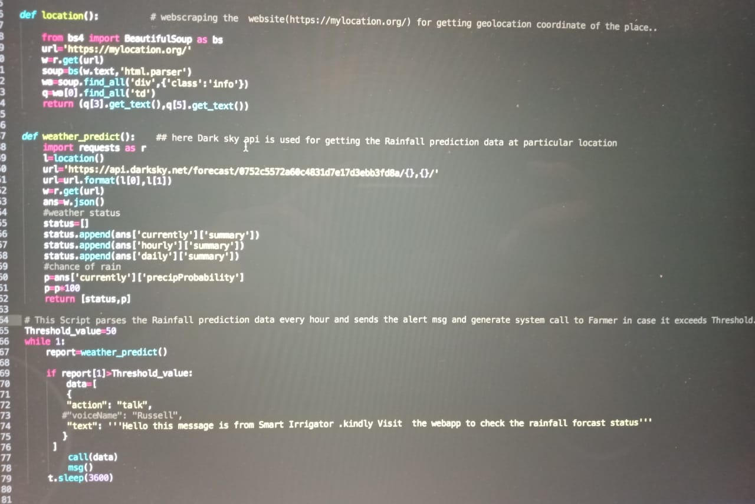

*SMS TRIGGER TO FARMER*

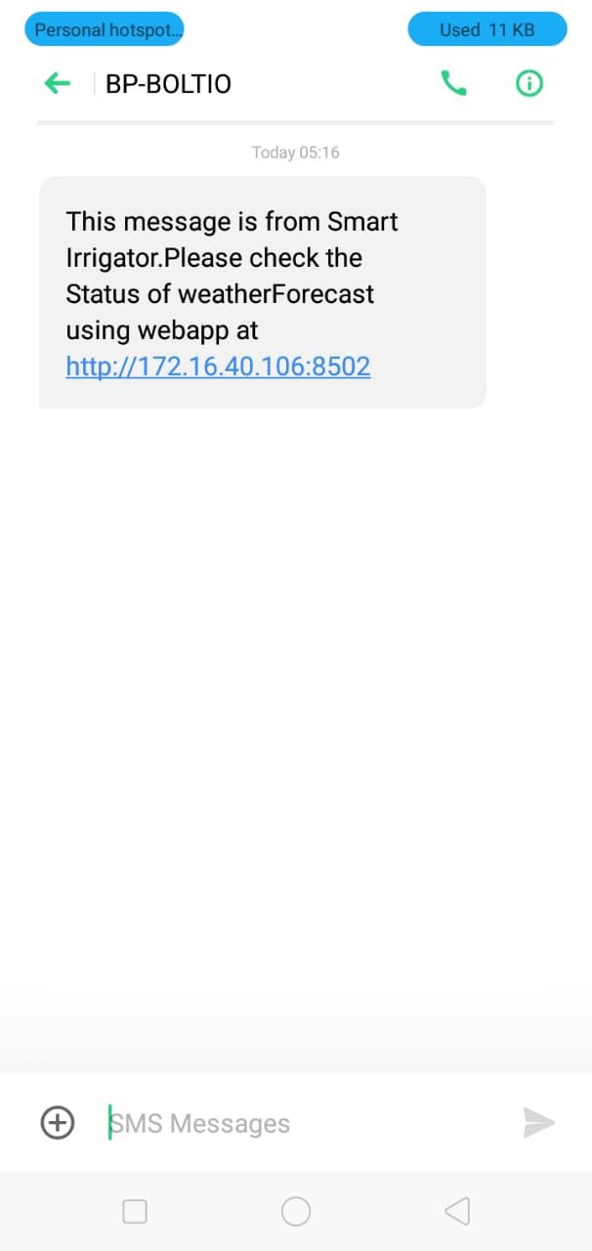

*SYSTEM GENERATED CALL ON FARMER MOBILE*

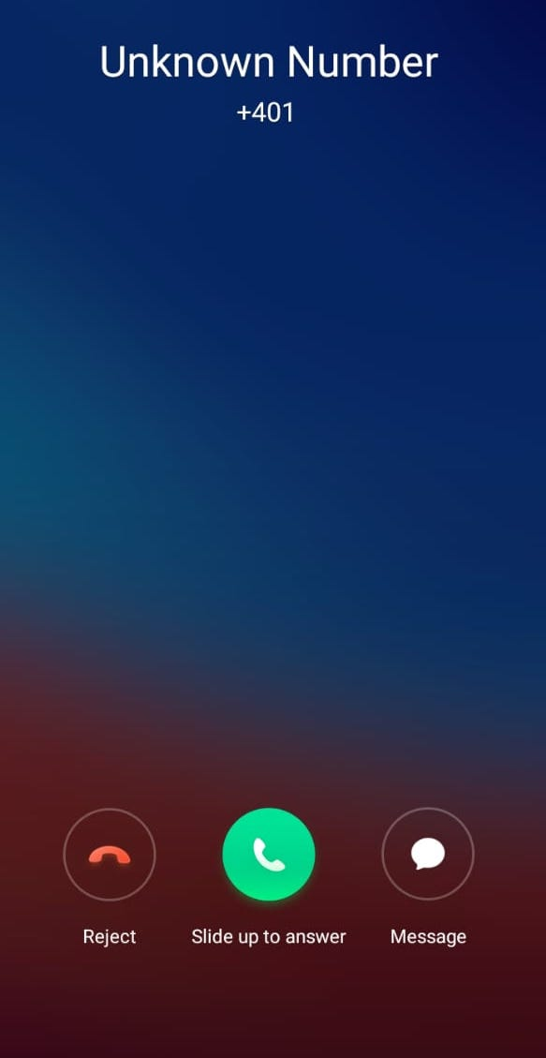

**CODE FOR WEBAPP FOR FARMER**

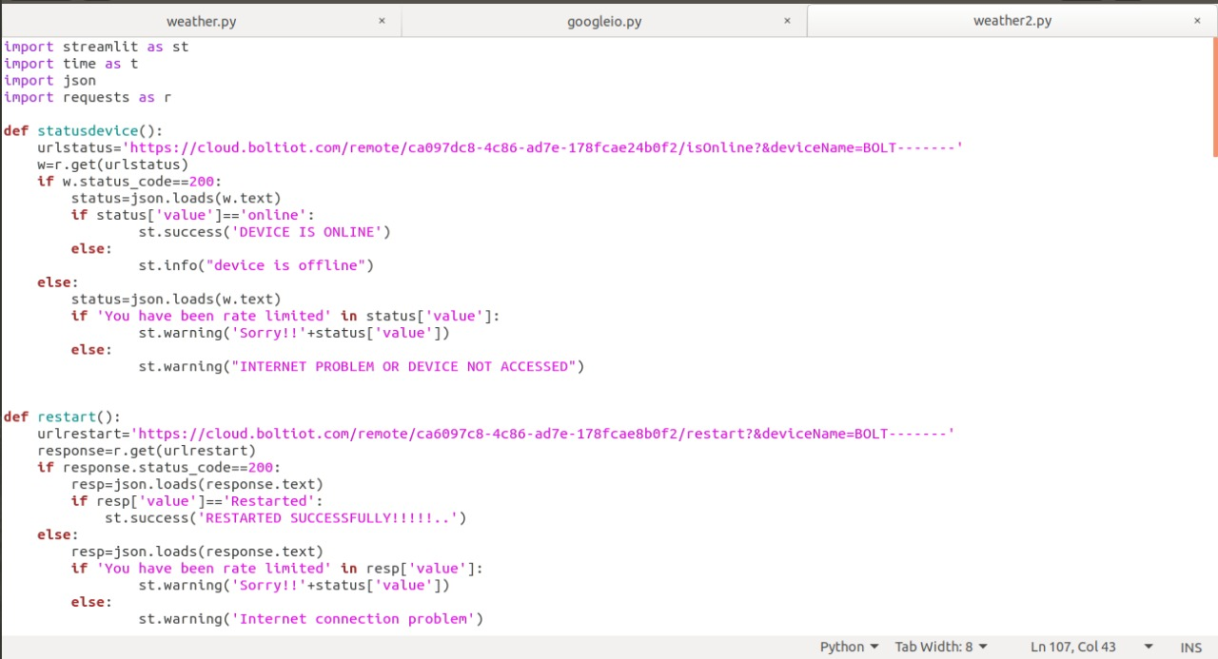

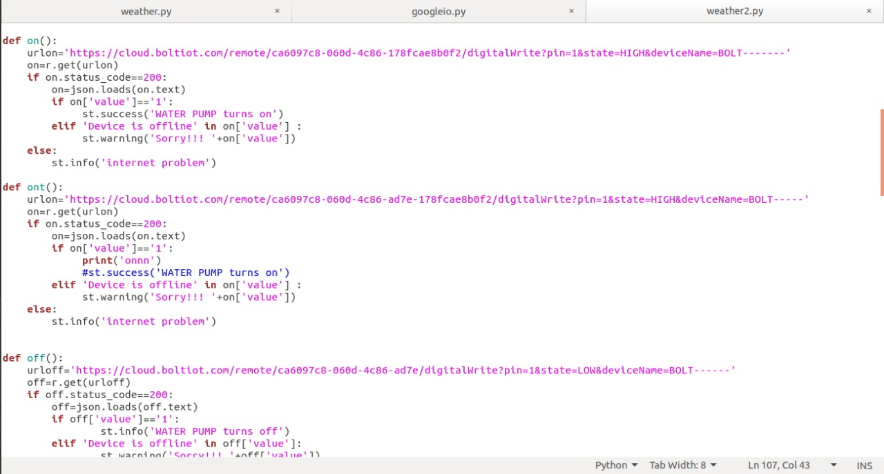

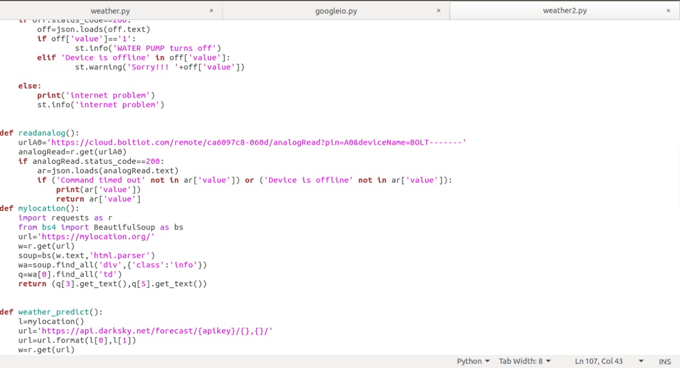

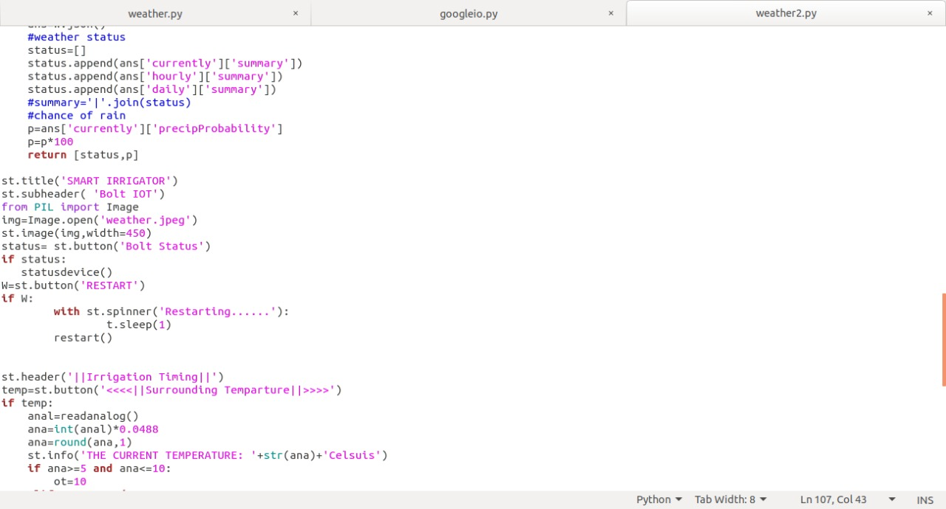

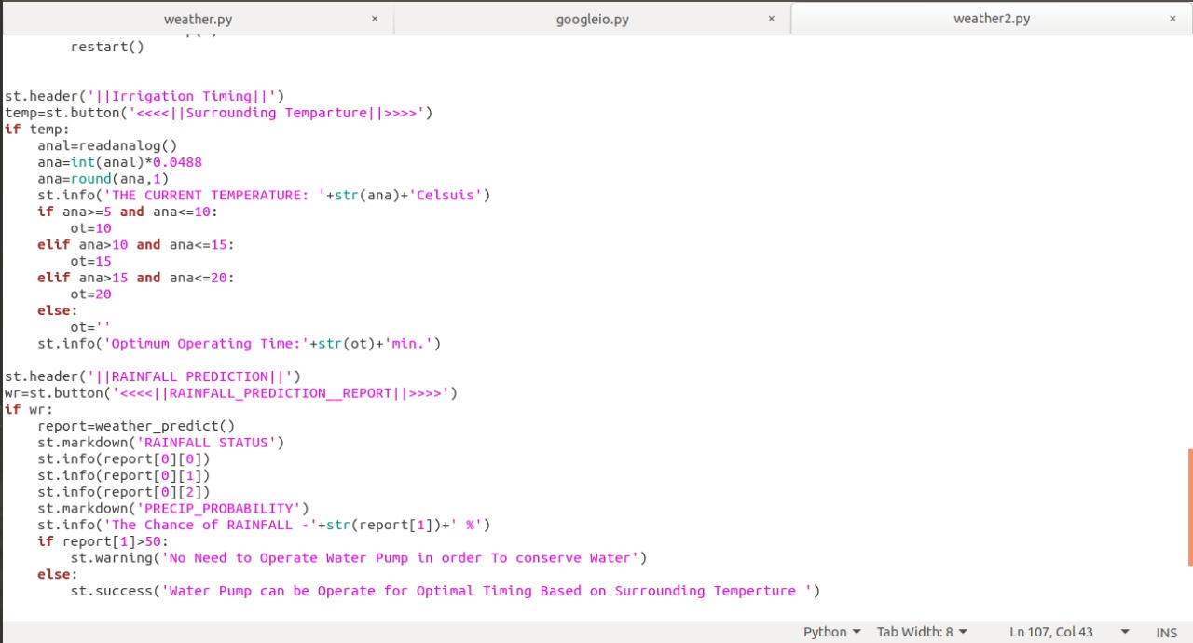

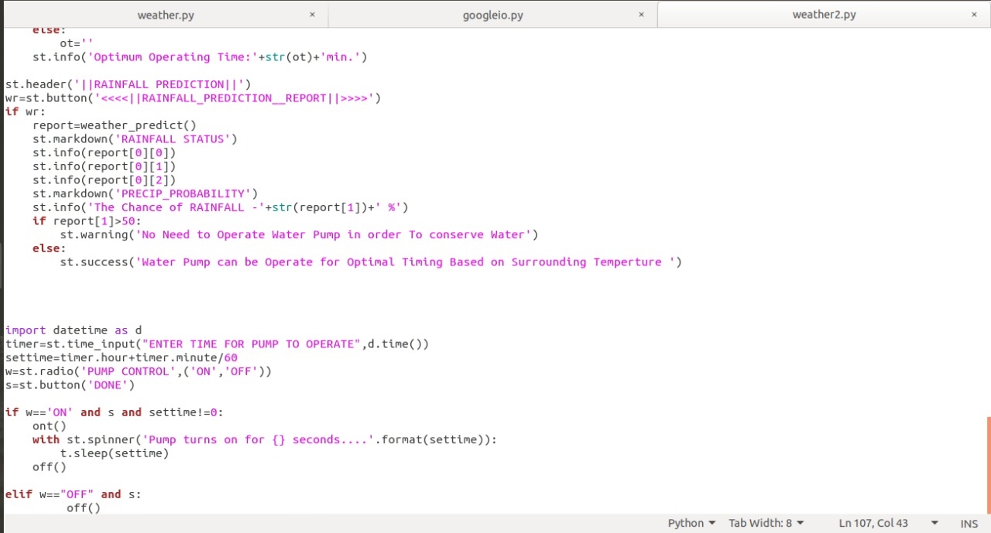

WEBAPP FOR FARMERS:-

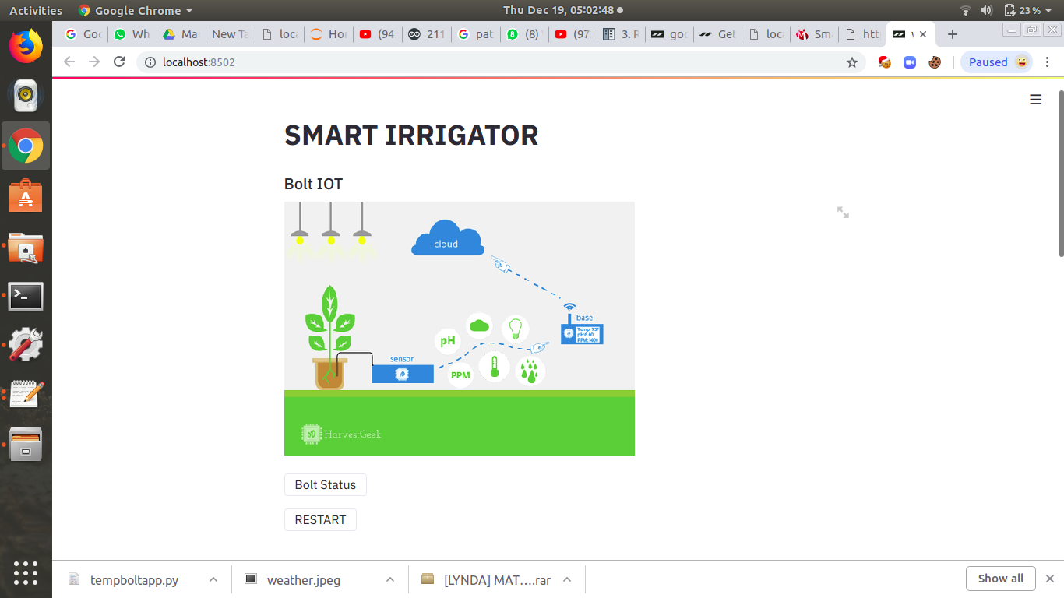

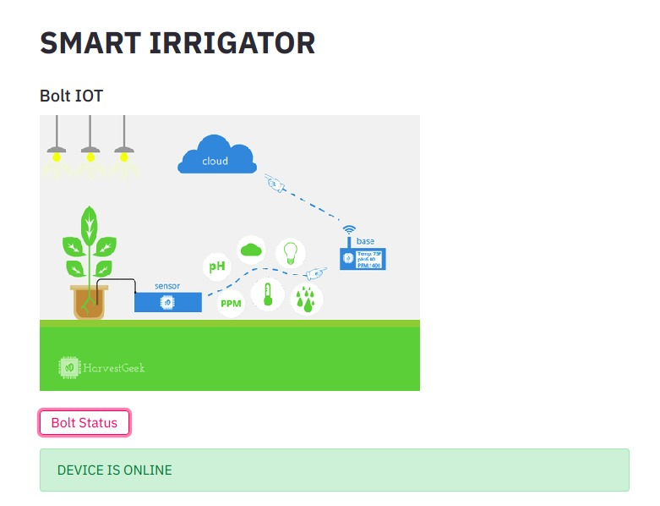

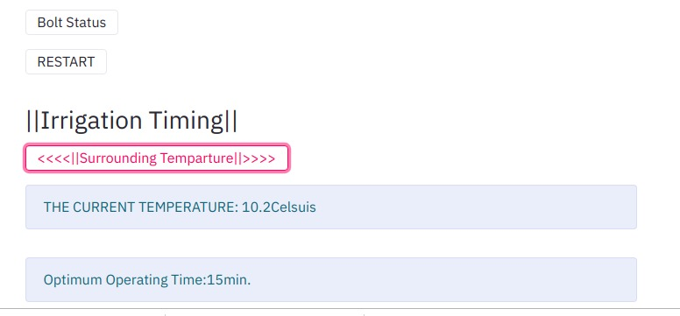

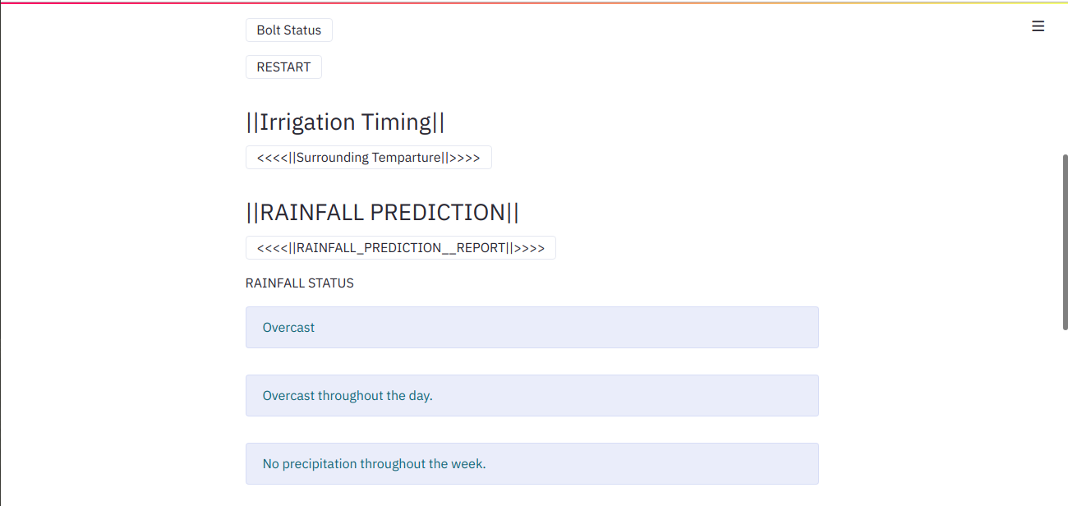

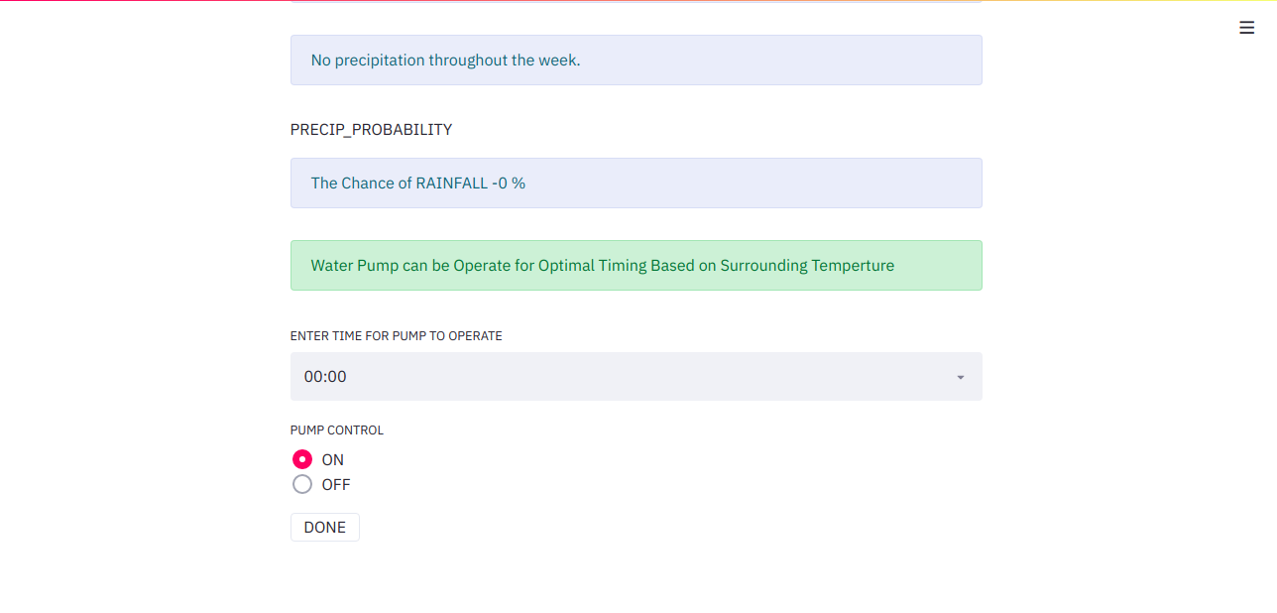

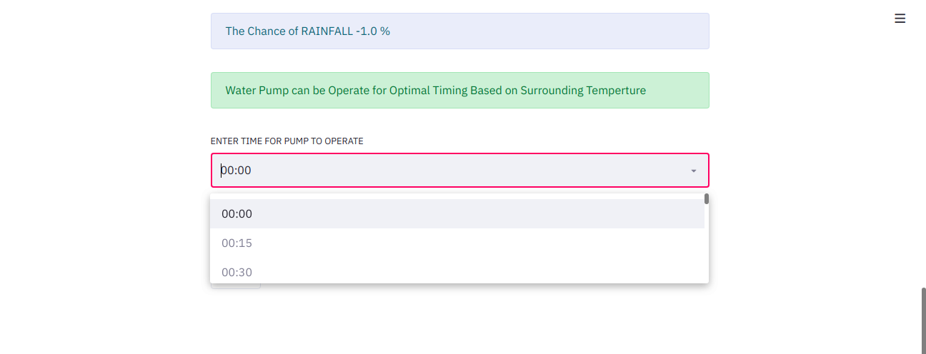

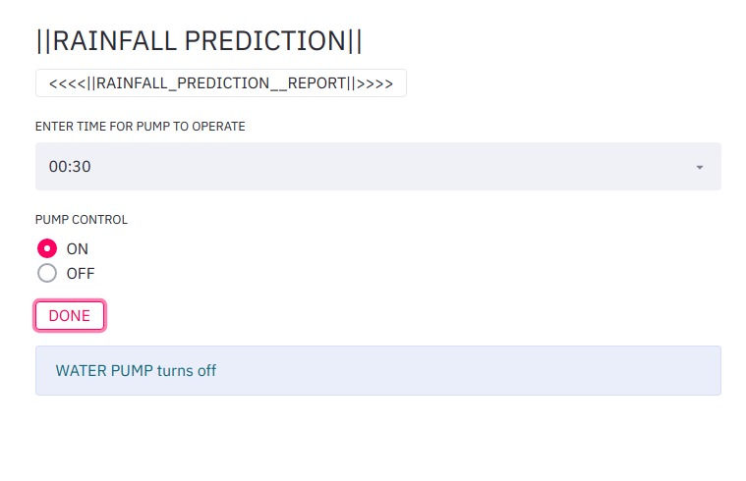

**REFERENCES:-**

1. <https://darksky.net/dev>
2. <https://streamlit.io/>
3. <https://www.dataquest.io/blog/web-scraping-beautifulsoup/>
4. <https://msg91.com/communications-api/>
5. <https://www.nexmo.com/>
6. <https://aws.amazon.com/ec2/>
7. <https://aws.amazon.com/lambda/>
8. <https://cloud.boltiot.com/>
9. <https://components101.com/lm35-temperature-sensor>